**ID Assignment**

**DUE DATE**:

**Midpoint** - Friday, 19th Nov 2021 2359, Week 5

**Final** - Friday, 3rd Dec 2021 2359, Week 7

Done by: Nuralfian - S10228111C

## 

**Table of Content**

**Overview** **3**

**Requirements** **3**

**Things to note** **3**

**Criteria** **4**

**Deliverable Details** **5**

**Assignment Rubrics** **6**

Development & Implementation 6

File structure 6

Readability 6

Comments 6

Compliant code 7

Robust code 7

**Ideas** **8**

100T Website - Click here 8

Evil Geniuses - Click Here 10

Valorant - Click Here 11

**Functions** **12**

**Color Palette** **12**

**Color Hex / RGB / CMYK** **12**

**Font Faces** **13**

**Pages to have** **14**

**Additional Resources** **15**

**Reference** **16**

## 

## **Overview**

Design and develop a **responsive website** a resume site for myself

## **Requirements**

* Build a static front-end responsive website using **HTML, CSS, Javascript** and **modern web development techniques**
* Design a front-end web application based on **sound design principles, accessibility**
* Use **version control software** to maintain, upload code
* Test and deploy a front-end web application to **Github**

## **Things to note**

1. Does the website address the needs of the intended audience?
2. Is the purpose of the website evident to the audience?
3. Has it been appropriately tested for cross browser compatibility, platforms and devices?
4. Are the aesthetics appealing and attractive for the intended audience?
5. Building skills in web development and design

## **Criteria**

| No. | Deliverable | Naming Convention | File Format |
| --- | --- | --- | --- |
| 1 | Wireframe | ID_StudentID_StudentName_Assg1_wireframe | **.xd** |
| 2 | Website files **HTML**, **CSS**, **Javascript** Includes item no.3 | ID_StudentID_StudentName_Assg1_website (only for submission folder naming) | All pages to have proper extension **.html** , **.css**, **.js**  **homepage to named as index.html** |
| 3 | Documentation. **README.md** | **README.md** | This file should be placed together with your website source codes |
| 4 | **Video** walkthrough (5 min) | ID_StudentID_StudentName_Assg1_VideoWalkthrough | **Mp4** or any playable video formats |

Include all original work wherever possible (.psd, .ai, .docx, etc.)

Note: Files should be properly named and structured. Failure to do so will result in heavy penalization of marks. Marks are given for proper file organization

## 

## **Deliverable Details**

| 1 | Wireframe | 1. Low-fidelity wireframe 2. Name artboards |
| --- | --- | --- |
| 2 | Website | 1. Fully website responsive 2. All pages have .html 3. Landing page to be named index.html 4. Organise HTML, CSS, Javascript with clear and well commented sections 5. No [deadlinks](https://www.pcmag.com/encyclopedia/term/dead-link) |
| 3 | README.md | 1. Try to follow [this README.md](https://github.com/immalcolm/interactivedev-readme-template) guide as possible. 2. Clear explanation of user audience intent and purpose 3. Identify and cater to which particular end-users or audience with what purpose they can come up with 4. State what is the website meant for 5. Attribute all external source code used |
| 4 | Video Walkthrough | 1. 5 min video to showcase the website 2. Explain design rationale clearly 3. Showcase features that you have implemented 4. Showcase the Javascript that is used |

## **Assignment Rubrics**

### **Development & Implementation**

Code demonstrates characteristics of ‘clean code’:

**Consistent and appropriate naming conventions within code and in file naming, e.g.**

* file names and class names, are descriptive and consistent
* for cross-platform compatibility, file and directory names will not have spaces in them

and will be lower-case only

* all HTML attributes and CSS rules, are consistent in format, follow standards for the language and are appropriate and meaningful

### **File structure**

* whenever relevant, files are grouped in directories by file type (e.g. an assets

directory will contain all static files and code may be organised into sub-directories

such as css, etc)

* there is a clear separation between custom code and any external files (for example,

library files are all inside a directory named 'libraries')

* files are named consistently and descriptively, without spaces or capitalisation to

allow for cross-platform compatibility.

### **Readability**

* id/class/attribute names clearly indicate their purpose
* code is indented in a consistent manner to ease readability and there are no

unnecessary repeated blank lines (and never more than 2)

* CSS code is split into well-defined and commented sections
* Semantic markup is used to structure HTML code
* HTML and CSS are kept in separate, linked files
* CSS files are linked to in the HTML file’s head element
* Errors are handled gracefully and users are notified of the problem where

appropriate.

### **Comments**

* all custom code files include clear and relevant comments explaining the purpose of

code segments

### 

### **Compliant code**

* HTML code passes through the official W3C validator with no issues
* CSS code passes through the official (Jigsaw) validator with no issues

### **Robust code**

* no logic errors are found when running code
* errors caused by user actions are handled
* inputs are validated when necessary

## **Ideas**

### 100T Website - [**Click here**](https://100thieves.com/)

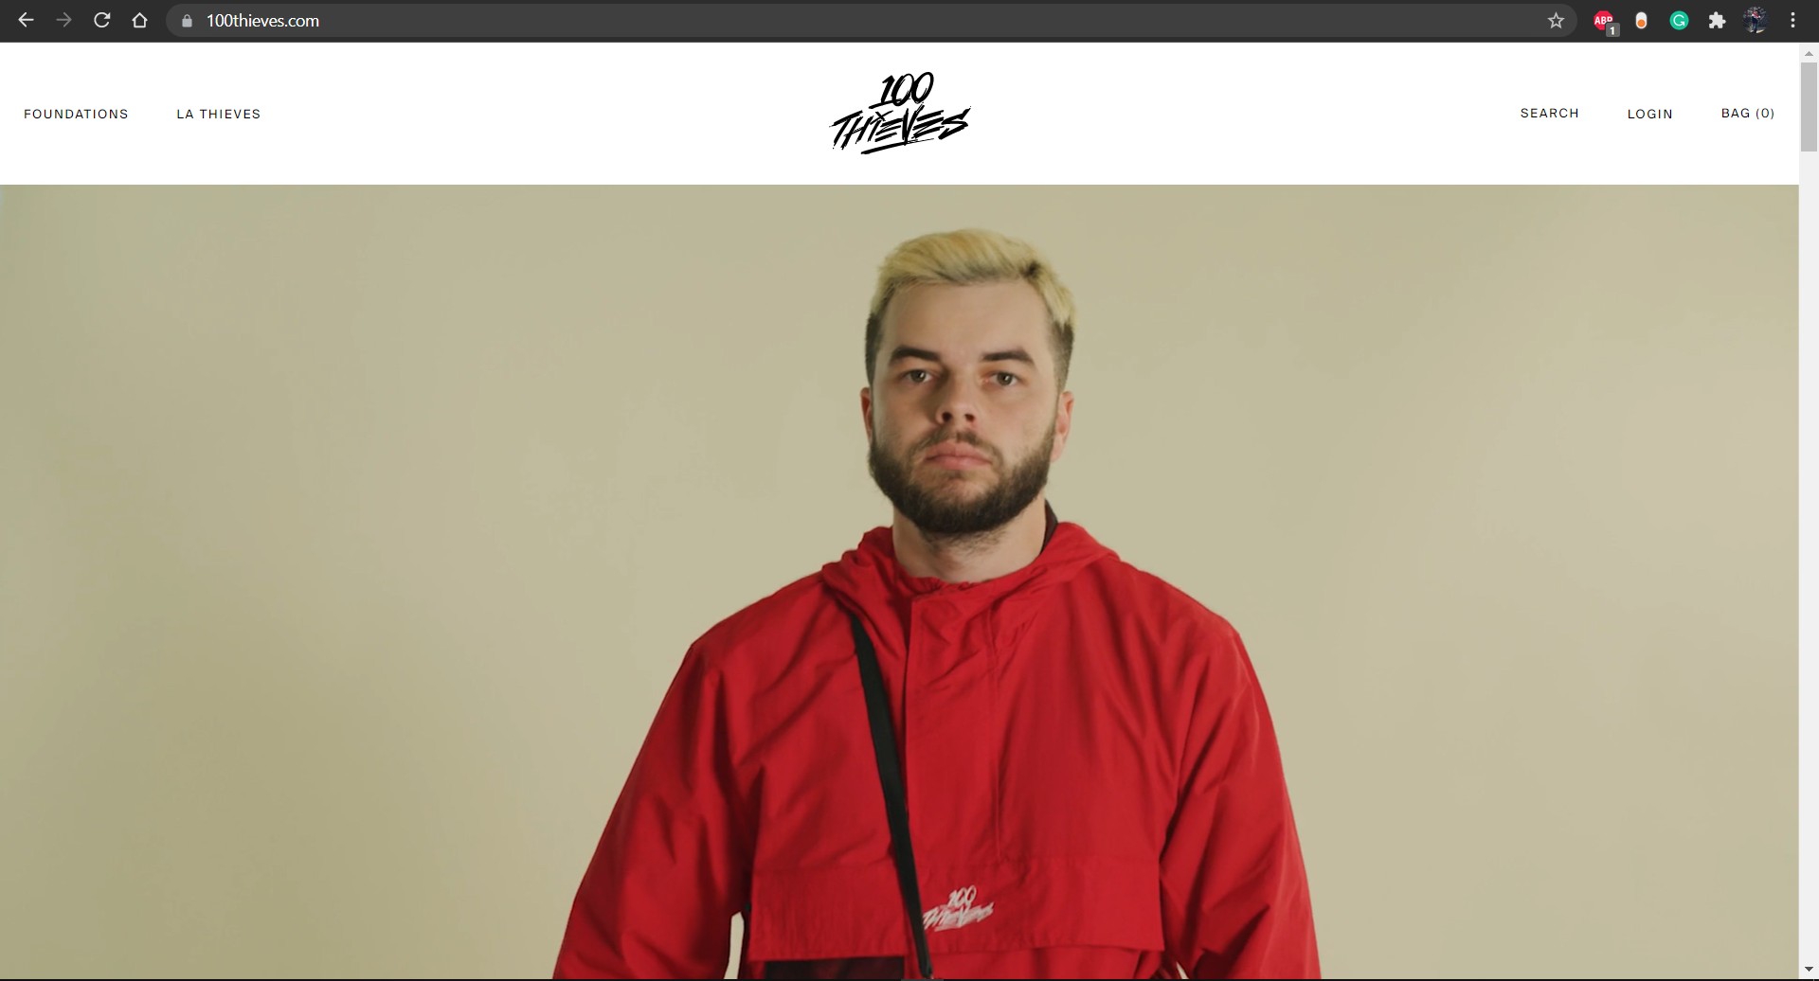

1. Video Background for main page
2. Header absolute to top when scrolling

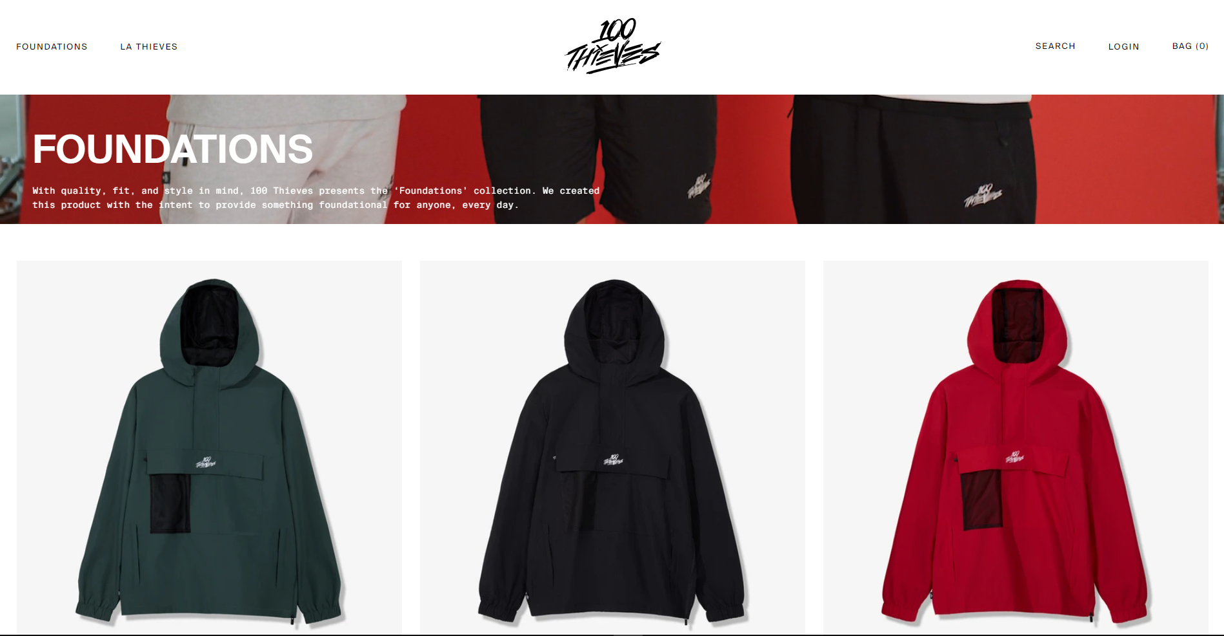

1. Text overlay of video
2. 3 grid box display product / images
3. Hover - show model picture

### Evil Geniuses - [**Click Here**](https://evilgeniuses.gg/)

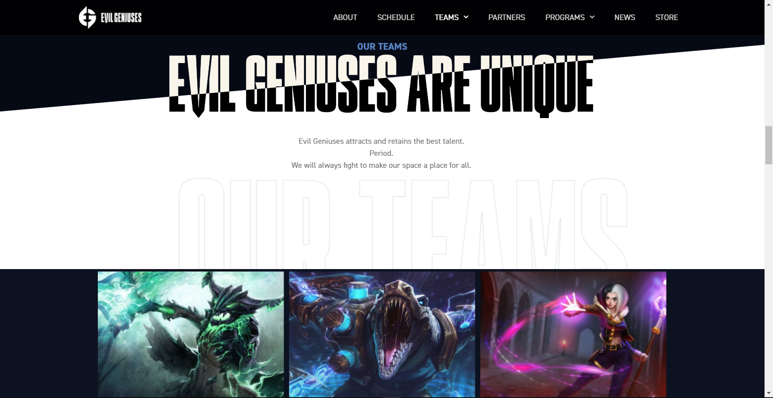

1. “EVIL GENIUSES ARE UNIQUE” header using mix-blend-mode: exclusion;
2. Hover picture animation to show title
3. Linear background for the line across the text using linear-gradient(175deg, #060A15 86%, #FFFFFF 86.1%)

### Valorant - [**Click Here**](https://playvalorant.com/en-sg/)

### 

1. Text stroke in the background

### Patrick David Portfolio - [**Click Here**](https://bepatrickdavid.com/)

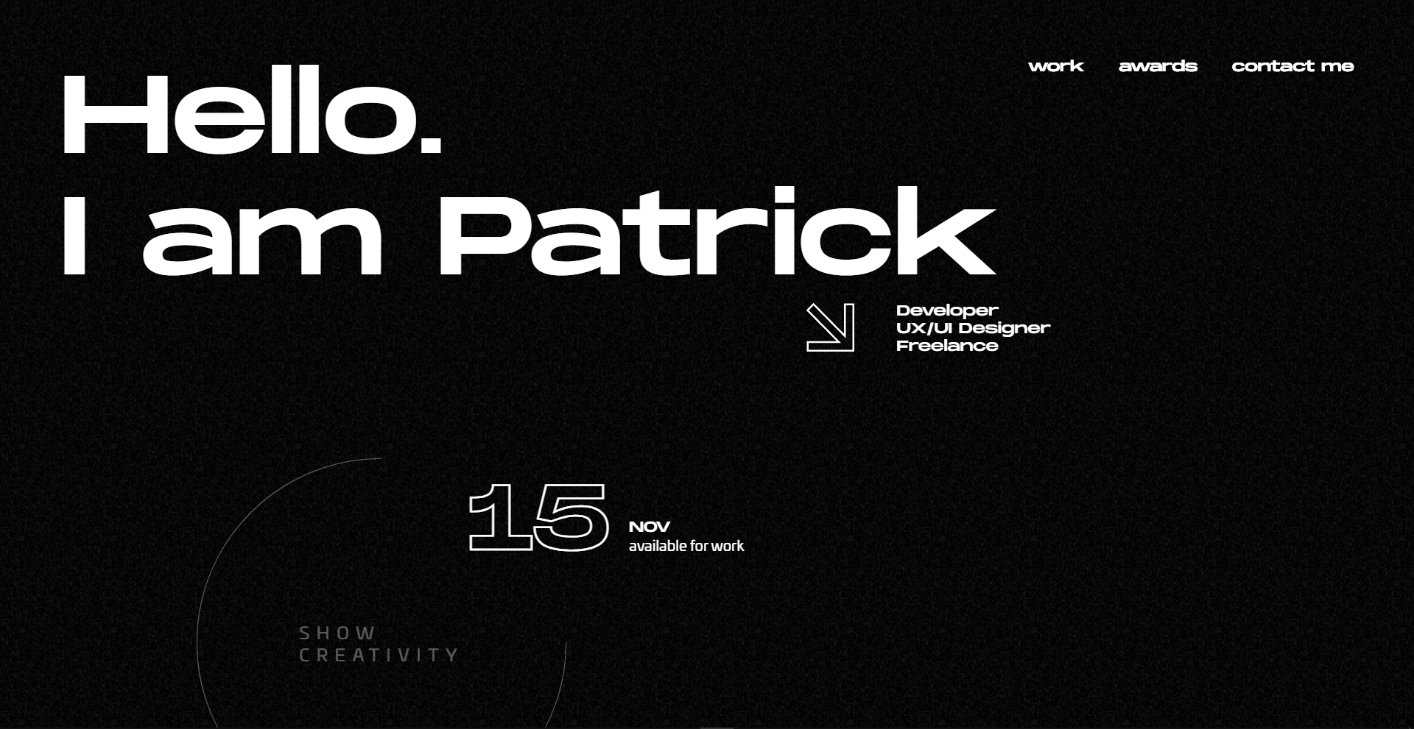

1. Simplistic look

## **Functions**

1. **Light / Dark mode**
2. **Hover Animations**
3. **Video Background**
4. **Parallax Scrolling**

## **Color Palette**

1. **White - Base Colour**
2. **Blue - Font Color - Navbar**
3. **Red - Accent**

**Dark Mode**

1. **Black - Base Colour**
2. **Blue - Font Color - Navbar**
3. **Red - Accent**

## **Color Hex / RGB / CMYK**

| **HEX: #2c66c2**  **HEX: #c28e2c**  **HEX: #c2432c**  **HEX:#000000** |
| --- |
| **R: 44 G: 102 B: 194**  **R: 194 G: 142 B: 44**  **R: 194 G: 67 B: 44**  **R: 0 G: 0 B: 0** |
| **C: 77 M: 47 Y: 0 K: 24**  **C: 0 M: 27 Y: 77 K: 24**  **C: 0 M: 65 Y: 77 K: 24**  **C: 80 M: 70 Y: 70 K: 100** |

## 

## **Font Faces**

1. Roboto
   1. Thin 100 italic
   2. Regular 400
   3. Medium 500
2. Righteous
   1. Regular 400

Import CSS

| <style>  @import url('https://fonts.googleapis.com/css2?family=**Righteous**&family=**Roboto:ital,wght@0,400;0,500;1,100**&display=swap');  </style> |
| --- |

CSS Font

| 1. font-family: 'Righteous', cursive; 2. font-family: 'Roboto', sans-serif; |
| --- |

## **Pages to have**

1. index.html - Landing Page
   1. aboutme.html - About me Page
   2. skillset.html - Skillset page
2. contactme.html - Contact Page
3. project.html - Project Page

## **Additional Resources**

1. Markdown of README.md - [Click Here](https://guides.github.com/features/mastering-markdown/)
2. Google Fonts - [Click Here](https://fonts.google.com/)

## **Reference**

Ann, N. (2021, October). Interactive Development [Assignment for ID]. In *Interactive Development*. Ngee Ann.